Context in android.

What exactly context is?

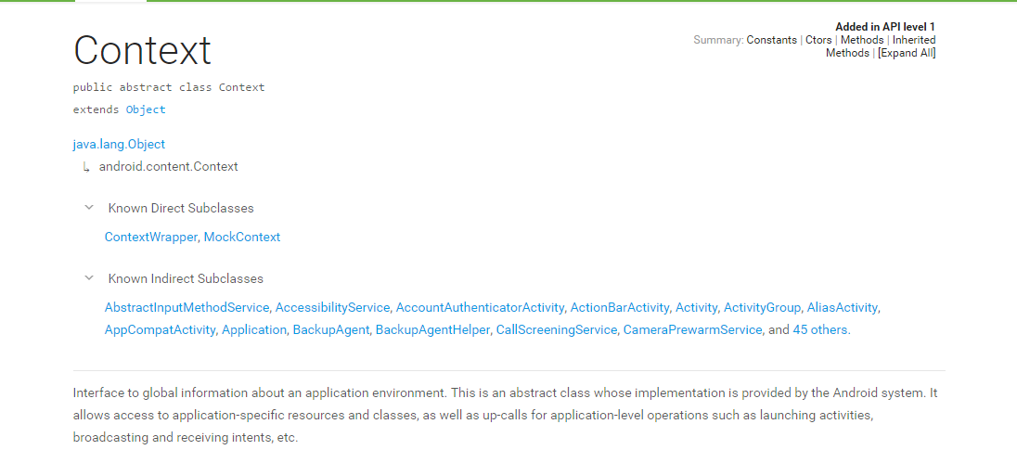

Activity is also inherited from context, so you can always use any method related to Context by passing **this** in any Activity. And can simply call method related to context like getResources() without need of context Object.

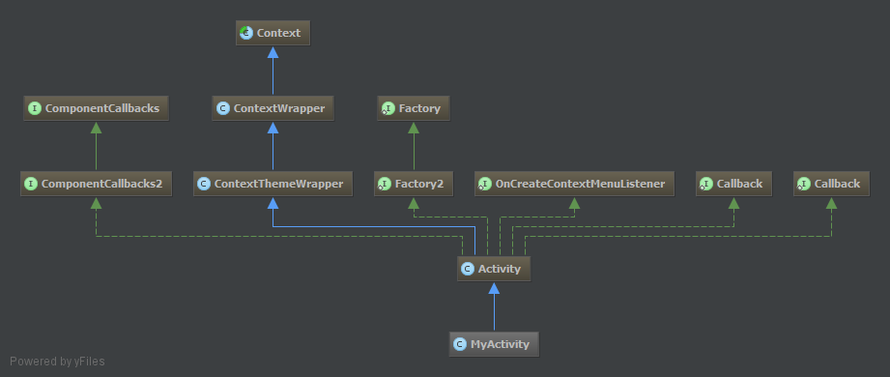

Context of current state of the application/object. It lets newly created objects understand what has been going on. And it’s abstract class.

[This is one of most useful answer](http://stackoverflow.com/a/16301475/5476209) for introduction of context, what it really is and all.

**Various methods for getting context.**

For Activities just use **this** [As activities itself own context] **or getContext()**

**getApplicationContext()** – This is context for whole application lifecycle and it’s attached to whole application [ **Activity.getApplication** ]

**getBaseContext()** is also a method but Developer documentation suggest not to use it. It’s used to getContext from another context.

What is difference between Activity and Application Context?

Activity context is tied to Lifecycle of Activity and Application context is available for whole Application.

When to use which?

getApplicationContext() – Use it when implementation is going to affect at whole application level and if any event that is related to activity life cycle then prefer Activity context instead.

Examples:

* Getting resources value, because all resources are accessible at Application level.
* Show Toast messages, you can use it.
* Service related tasks as they are not dependent on Activities lifecycles
* Broadcast receivers registering,sending

Activity Context

* Always for loading views
* Call another activity if you wanna manage Lifecycle
* Dialog creation.

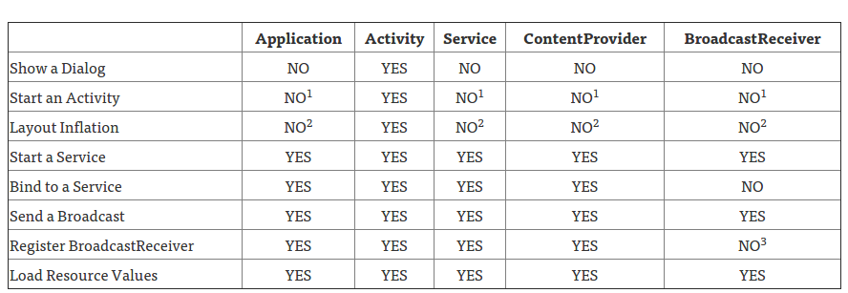

[Example of usage of Context](http://stackoverflow.com/a/13945633/5476209)

Use Application context everywhere in App the static way

<http://stackoverflow.com/questions/14057273/android-singleton-with-global-context>

Why we can’t access activity context in OnClickListner:

<http://stackoverflow.com/questions/2002288/static-way-to-get-context-on-android?rq=1>

Memory leaks post:

<https://android-developers.googleblog.com/2009/01/avoiding-memory-leaks.html>

Different methods to get contexts and difference between all:

<http://stackoverflow.com/questions/10641144/difference-between-getcontext-getapplicationcontext-getbasecontext-and/15175006#15175006>